**Bigdata Assignment 3.8**

Started the Hbase shell :

**start-hbase.sh**

**hbase shell**

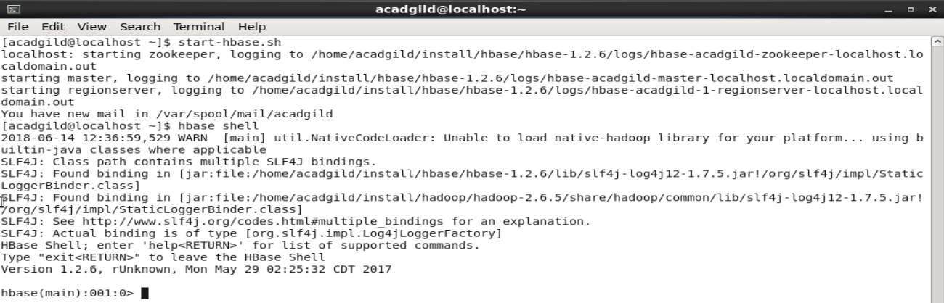

Problem 1:

Create an HBase table named 'clicks' with a column family 'hits' such that it should be able to store last 5 values of qualifiers inside 'hits' column family.

Solution -

* Table 'clicks' wa screated and values were inserted

**create 'clicks' , {NAME='hits',VERSIONS=>5}**

**put 'clicks' , '192.168.1.1' , 'hits:user1', '1st'**

**put 'clicks' , '192.168.1.1' , 'hits:user1', '2nd'**

**put 'clicks' , '192.168.1.1' , 'hits:user1', '3rd'**

**put 'clicks' , '192.168.1.1' , 'hits:user1', '4th'**

**put 'clicks' , '192.168.1.1' , 'hits:user1', '5th'**

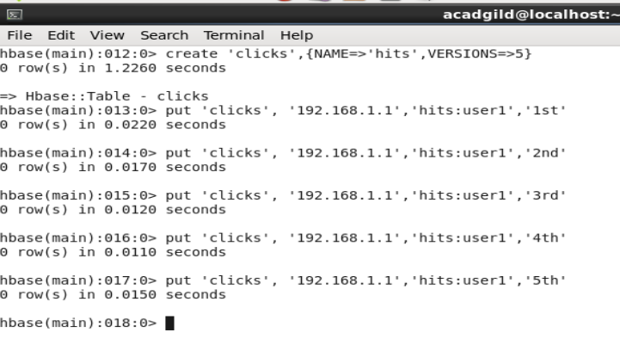

* To display the values

**scan 'clicks' , {COLUMN=>'hits:user1',VERSIONS=>5}**

In the above screenshot it is evident that we got the previous 5 values for the particular column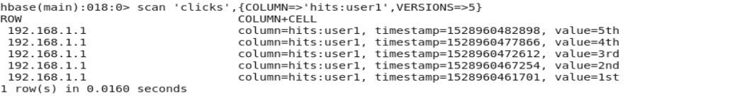

* We added different columns

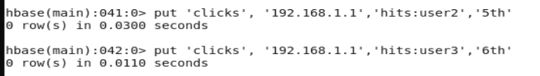

* To display the values

**scan 'clicks' , {NAME=>'hits',VERSIONS=>5}**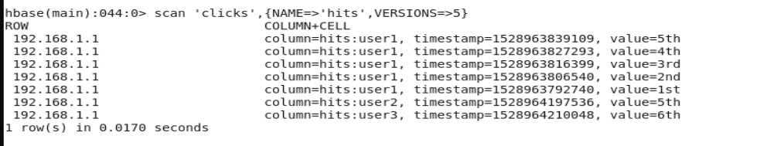

In the above screenshot , we observe that for each particular hits column we can retrieve 5 previous values

Problem 2

Add few records in the table and update some of them. Use IP Address as row-key. Scan the table to view if all the previous versions are getting displayed.

Solution -

* We updated some records

**put 'clicks' , '192.168.1.1' , 'hits:user2', '7th'**

**put 'clicks' , '192.168.1.1' , 'hits:user3', '4th'**

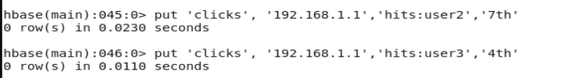

* The content of the table is displayed containing previous 5 versions.

**scan 'clicks',{NAME=>'hits',VERSIONS=>5}**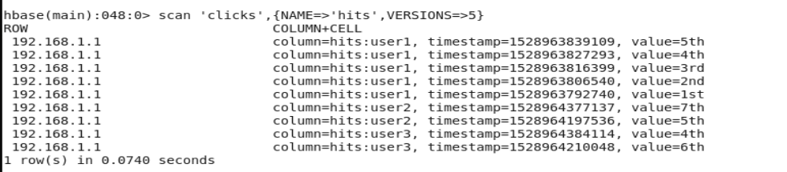

In the avove screenshot it is evident taht as we have set versions to 5 , after updating some records , we are gettings its previous value and the current values.